Subject Code | : | CEUE203 | Semester | : | 3 | Academic Year | : | 2026-27
Subject Name | : | Object-Oriented Programming

 | Practical 2
Program: 2.1 | Smart thermostat (Thermostat.java, main in this file) (a) Create class Thermostat with private String location, private int temperature, private static final int MIN=16 and MAX=30, and private static int activeCount=0. (b) Constructor(location, startTemp): store location; set temperature to startTemp if it is within MIN..MAX else 22; increment activeCount. CO1 PO1, PO2, PO3 Practical Number CO/PO (c) Constructor(location): chain with this(location, 22). (d) raise(): if temperature < MAX add 1, else print “Already at maximum (30)”. (e) lower(): if temperature > MIN subtract 1, else print “Already at minimum (16)”. (f) Add getTemperature() (no setter) and static getActiveCount(). (g) In main: create two thermostats, call raise() 10 times then lower() 20 times in loops (printing the temperature each time), then print getActiveCount(). Expected output: temperature rises to 30 then “Already at maximum”, falls to 16 then “Already at minimum”, count 2.
Code | class Thermostat  {  private String location;  private int temperature;  private static final int MIN=16,MAX=30;  private static int ActiveCount=0;  Thermostat(String location,int temperature)  {  if(temperature>=MIN && temperature<=MAX)  {  this.location=location;  this.temperature=temperature;  ActiveCount++;  }  else  {  this.location=location;  this.temperature=22;  ActiveCount++;  }  }  Thermostat(String location)  {  this(location,22);  }  public int getTemperature()  {  return temperature;  }  public String getLocation()  {  return location;  }  public static int getActiveCount()  {  return ActiveCount;  }  public void raise()  {  if(temperature<MAX)  {  temperature+=1;  }  else  {  System.out.println("Already at maximum (30)");  }  }  public void lower()  {  if(temperature>MIN)  {  temperature-=1;  }  else  {  System.out.println("Already at minimum (16)");  }  }  }  public class Thermostat_prac  {  public static void main(String[] args)  {  Thermostat t1=new Thermostat("hall");  Thermostat t2=new Thermostat("bedroom",25);  int i;  for(i=0;i<10;i++)  {  t1.raise();  int temp=t1.getTemperature();  String loc=t1.getLocation();  System.out.print("Location : "+ loc);  System.out.println(" temperature : "+ temp);  }  for(i=0;i<20;i++)  {  t1.lower();  int temp=t1.getTemperature();  String loc=t1.getLocation();  System.out.print("Location : "+ loc);  System.out.println(" temperature : "+ temp);  }  for(i=0;i<5;i++)  {  t2.raise();  int temp=t2.getTemperature();  String loc=t2.getLocation();  System.out.print("Location : "+ loc);  System.out.println(" temperature : "+ temp);  }  int cnt=Thermostat.getActiveCount();  System.out.println("active count : "+ cnt);  }  }
Output | 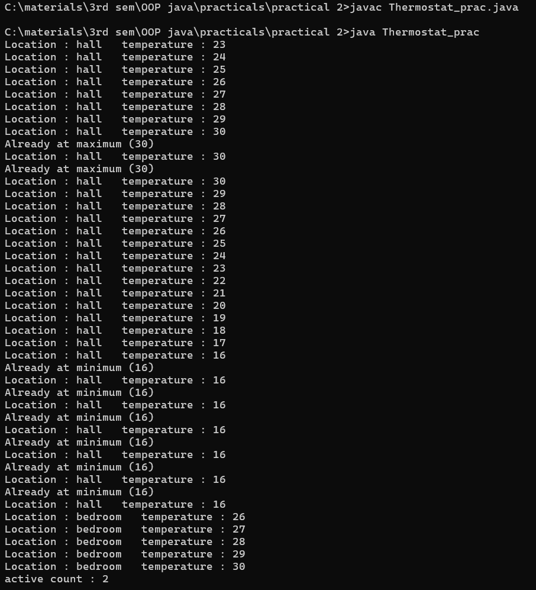

Program: 2.2 | Cinema show (CinemaShow.java, main in this file)  (a) Create class CinemaShow with private String title, private int seatsAvailable, private final int capacity, and private static int totalBooked=0. (b) Constructor(title, capacity): set both and seatsAvailable = capacity. Constructor(title): chain with this(title, 100). (c) book(int n): if n ≤ seatsAvailable, reduce seatsAvailable by n, add n to totalBooked, return true; else return false unchanged. (d) cancel(int n): increase seatsAvailable by n but never above capacity. (e) Add getSeatsAvailable() and static getTotalBooked(). (f) In main: run a sequence of book and cancel calls, printing the result and seats after each, then print getTotalBooked(). Expected output: booking more than available prints false and leaves seats unchanged; totalBooked equals the successful bookings.
Code: | class Cinema  {  private String title;  private int seatsAvailable;  private final int capacity;  private static int totalBooked=0;  Cinema(String title,int capacity)  {  this.title=title;  this.capacity=capacity;  this.seatsAvailable=capacity;  }  Cinema(String title)  {  this(title,100);  }  public boolean book(int n)  {  if(seatsAvailable>=n)  {  seatsAvailable-=n;  totalBooked+=n;  return true;  }  else  {  return false;  }  }  public void cancel(int n)  {  if(seatsAvailable+n<=capacity)  {  seatsAvailable+=n;  }  else  {  seatsAvailable=capacity;  }  }  public int getSeatsAvailable()  {  return seatsAvailable;  }  public static int getTotalBooked()  {  return totalBooked;  }  public void display()  {  System.out.println("title :"+title);  System.out.println("seats available :"+getSeatsAvailable());  System.out.println("total booked :"+getTotalBooked());  }  }  public class cinema_prac  {  public static void main(String[] args)  {  Cinema c1=new Cinema("movie1",100);  Cinema c2=new Cinema("movie2",200);  boolean result=c1.book(50);  System.out.println("booking result :"+result);  c1.display();  c1.cancel(20);  c1.display();  result = c1.book(100);  System.out.println("booking result : " + result);  c1.display();  result=c2.book(20);  System.out.println("booking result :"+result);  c2.display();  c2.cancel(30);  c2.display();  System.out.println("Final Total Booked : " + Cinema.getTotalBooked());  }  }

Output | 